4

September 2026 CMS
Monday | Tuesday | Wednesday | Thursday | Friday | 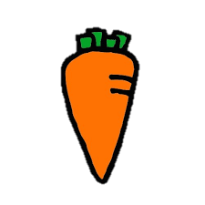  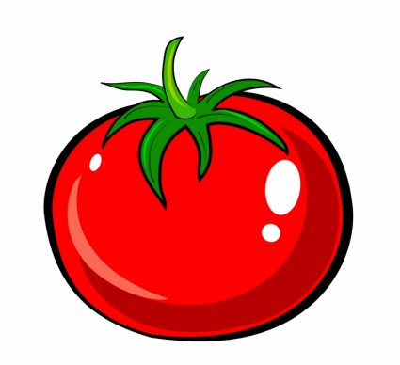  Every week, an  additional ¼  cup of veggies is offered to meet the USDA Federal guidelines for ¾ cup red/orange vegetable subgroup. This alternates weekly between baby carrots and grape tomatoes.  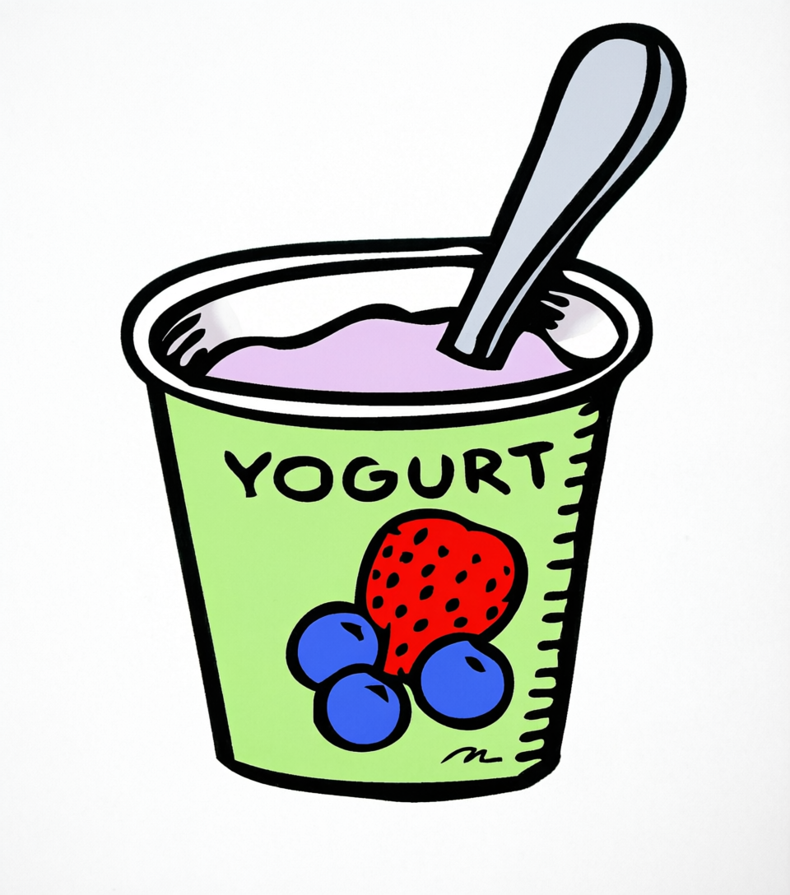  In addition to  the daily hot  entree and cold alternative, a third option is available.  - Yogurt w/a Cheese Stick OR Sunflower Seeds, & Assorted Bread  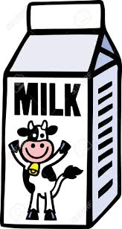  8 oz. nonfat  unflavored,  nonfat flavored, or 1% unflavored milk served daily.  Please visit https://westsidecommunityschoolsne.mealviewer.net/#home for the most up-to-date menus. Menus subject to change.   Denotes PORK in the product.  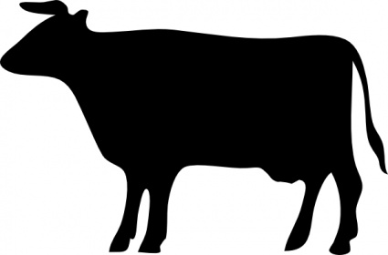 Denotes BEEF in the product  Vecteezy.com
31  Hot Dog on a Bun  Or-Sunbutter & Jelly  Sandwich w/a  Cheese Stick  Baked Beans  Mixed Fruit |   1  Grilled Cheese  Sandwich  Or- Ham & Cheese  Hoagie  Steamed Carrots  Pineapple | 2  Pizza Hut Pizza  Or- Tuna Salad on 9  Grain Bread  Romaine Salad with  Croutons  Crisp Apple | 3  Popcorn Chicken with  a Dinner Roll  Or- Asian Chicken  Wrap  Golden Corn  Watermelon Farm to School | 4  Macaroni & Cheese  with a Soft Pretzel  Or- Turkey & Cheese  Hoagie  Seasoned Green Beans  Craisins  Adult Salad: Chef Salad
7    No School | 8  Cheese Dunkers with  Pizza Sauce  OR – Italian Hoagie  Broccoli  Applesauce | 9  Fried Chicken  Drumstick with  Assorted Bread  Or- Chicken Salad on  9 Grain Bread  Mashed Potatoes with  Gravy  Banana | 10  Walking Taco with  Lettuce & Cheese  Or- Southwest  Chicken Wrap  Chili Beans  Cantaloupe Farm to School | Patriot Day 11  French Toast Sticks  with a Chicken  Sausage Patty  Or- Turkey & Cheese  Hoagie  Cinnamon Yams  Mandarin Oranges  Adult Meal: Bean Dip
14  Cheesy Nachos  Or-Sunbutter & Jelly  Sandwich w/a Cheese  Stick  Seasoned Black Beans  Mixed Fruit | 15  Cheesy Chicken Philly  Sandwich  Or- Ham & Cheese  Hoagie  California Blend  Vegetables  Chilled Pears | 16  Pizza Hut Pizza  Or- Tuna Salad on 9  Grain Bread  Romaine Salad with  Croutons  Fruit Slushy | Constitution Day 17  BBQ Pulled Pork  Sandwich  Or- Turkey & Cheese  Hoagie  Sweet Potato Waffle  Fries  Watermelon Farm to School Rice Krispie Treat | 18  Cheeseburger  Or- Chicken Bacon  Ranch Wrap  Jazz’d French Fries  Pineapple  Adult Salad: Southwest Chicken Salad
21  Corn Dog (chicken)  Or- Sunbutter & Jelly  Sandwich w/a Cheese  Stick  Baked Beans  Chilled Peaches | Autumn Equinox 22  1st Day of Fall  Chicken Alfredo with a  Ciabatta Roll  OR – Italian Hoagie  Fresh Broccoli  Orange Smiles | 23  Crispy Chicken  Sandwich  Or- Chicken Salad on  9 Grain Bread  Garden Peas  Banana | 24  Pancakes with a  Chicken Sausage  Patty  Or- Asian Chicken  Wrap  Glazed Carrots  Cantaloupe Farm to School | 25  Meatball Sub  Or- Turkey & Cheese  Hoagie  Italian Blend Vegetables  Crisp Apple Farm to School  Adult Salad: Chicken Bacon Strawberry
This Institution is an equal opportunity provider.

